Recrystallization/ Melting Point Lab Report

Acacia White
Organic Chemistry Lab
Dr. Kiren

Purpose:
During our experiments we used the process known as “recrystallization" to remove impurities and grow a perfect crystal lattice. We also examined the melting points of our samples to indicate whether a solid is pure or impure by observing if the sample melts over a narrow range or a large temperature range.
Introduction:
The Diels-Alder reaction is a reaction that adds a diene (Cyclopentadiene) to an alkene (Maleic Anhydride) and converts them to produce a cyclohexene. One of the most common methods of purifying organic compounds is using the process known as recrystallization. During recrystallization, an impure solid compound is dissolved in a solvent and then allowed to crystallize. As the compound crystallizes, the molecules of the other compounds dissolved in the solution are removed from the crystal lattice, producing a pure solid [1]. Determining the melting point of a compound is also a method used to indicate if a substance is pure. Pure substances have narrow melting ranges, whereas impure substances have large broader melting ranges [2].
Procedure:
First we performed a diels-alder reaction. We weighed 0.2 g of Maleic Anhydride and dissolved it in1 mL of Ethyl acetate and then added 0.2 ml of Cyclopentadiene. We then added 1 mL of Hexane to generate a reaction, and after continuous mixing, the mixture became cloudy. The mixture was then filtrated through a Hirsch funnel, and the solid was collected.
Next we performed our recrystallization experiment. We weighed 50 mg of benzoic acid, added 1 ml of distilled, and stirred the mixture for several minutes. We used a pipette to remove our mixture from the test tube, without the sand at the bottom of the tube. We let the mixture slow-cool for 5 minutes and then placed the mixture in an ice-bath for 5 minutes. We attached the "wilfilter" to our test tube and placed it upside-down in a centrifuge tube. We centrifuged our mixture for 4 minutes and collected the solid from the tube.
Last we performed our melting point experiment. We took three different samples, Urea + Cinnamic acid, Mixture, and Diels-alder product. We took 1 mg of each sample and separately measured the melting points of each sample.

Data/Results:
After our Diels-alder reaction we weighed .183 g of our product. To find the percent yield of our product we divided our practical yield (.183 g) by our theoretical yield (.33 g) and multiplied the dividend by 100 which gave us a percent yield of 55.5% Fig. 1. We observed the melting points of all three of our samples; Urea + Cinnamic Acid (M.P= 130° C), Mixture (M.P= 98° C), and Diels-Alder (M.P= 144° C).
Fig. 1
$\frac{Pract.}{Theo.}$ = $\frac{.183 g}{.33 g}$ x 100 = 55.5%

Table:
 | M.W | M.P | B.P | Density
Cyclopentadiene | 66.1 g/mol | -90° C | 41° C | 786 kg/m³
Maleic Anhydride | 98.06 g/mol | 52.6 ° C | 202° C | 1.48 kg/m³
Benzoic acid | 122.12 g/mol | 122.41° C | 249.2° C | 1.27 kg/m³
Ethyl Acetate | 88.11 g/mol | -83.6° C | 77.1° C | 897 kg/m³
Hexane | 86.16 g/mol | -95° C | 68.5° C | 655 kg/m³

Structure:
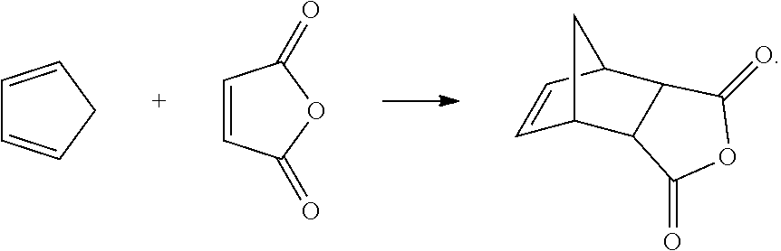
Discussion/Conclusion:
As we concluded our experiment we found that one of our samples (Mixture) was impure, whereas the other two samples (Urea + Cinnamic Acid & Diels-Alder) measured abnormal melting points. We observed that there could be two explantions to the abnormal melting points of our two samples; there was too compund used or the samples were exposed to an excessive amount of heat. Both explanations are viable theories to why our samples were exhibited abnormal melting points.

Reference:
- https://erowid.org/archive/rhodium/chemistry/equipment/recrystallization.html
- http://www.wiredchemist.com/chemistry/instructional/laboratory-tutorials/determination-of-melting-point
- JME molecule editor

