Acacia White Lab. Partner: Hector Mendoza

Distillation of an Unknown Lab
Organic Chemistry Exp. #2

Purpose:

The purpose of this experiment was to purify or separate the liquid when we heating the solution to a boiling point. We used a simple distillation technique to differentiate the liquids based on their different boiling points. In this experiment heat was used to produce the vapors that form will the component of the mixture that boils at the lowest temperature. The vapors cooled and collected in flask aside of the burner. The leftover solution after complete separation, is the component of the mixture with the higher boiling point. The product with the higher boiling point is also purified. As distillation progressed, the concentration of the lowest boiling component steadily decreased. The temperature within the apparatus will begin to change and increase until the boiling point of the next-lowest-boiling compound is approached, because the compound is no longer mixed. Temperature does stabilize, after another pure fraction of the distillate, primarily the compound that boils at the second lowest temperature is collected. This process can be repeated until all the fractions of the original mixture have been separated. We can determine an unknown substance based on it boiling point.

Procedure:

First we gathered a Bunsen Burner, flask, thermometer, stir bar, unknown solution, and a side flask. We put the unknown solution into the flask with the stir bar inside of a container (with sand) and heated the apparatus. We let the Bunsen burner get hot, and watched for boiling and steaming.

Observations:

At approximately 30 degrees Celsius our unknown solution began to drip. This was also 4 minutes after we began heating. The temperature began to rise and then, at approximately 46 degrees Celsius the dripping seemed have increased. Lastly, at roughly 55-60 degrees Celsius we observed drips at 22 drops per minute.

Data/ Results:

If we look at many charts, (the one provided during lab) then we can locate the chemical with a boiling point of roughly 60 degrees Celsius. Chloroform, according to pubmed, has a boiling point of 61.2 degrees Celsius.

Figures:

For Chloroform:
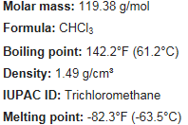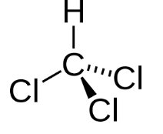

References:

National Center for Biotechnology Information. PubChem Compound Database; CID=6212, https://pubchem.ncbi.nlm.nih.gov/compound/6212 (accessed Sep. 18, 2016).

